**Red Orchestra Multiplayer Level Prototyping Exercise**

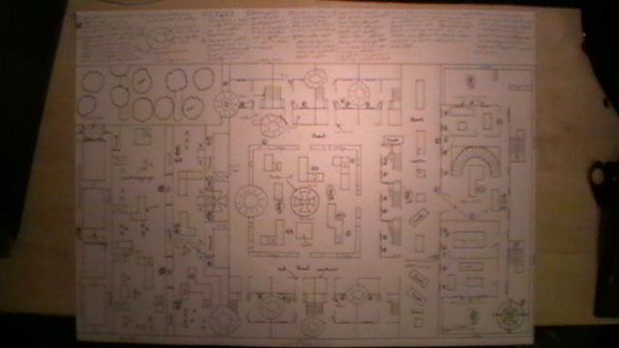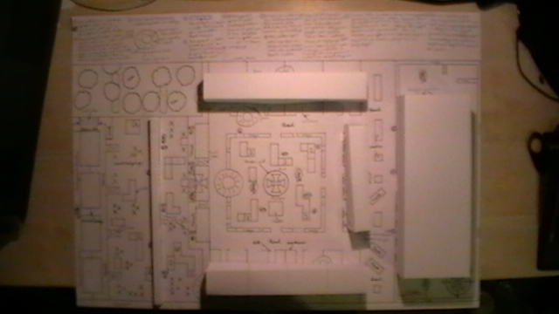This map is an infantry only map, based in a small village in the French countryside, featuring houses, roads, a park, a slope, small wood and a mansion. The map is separated into three stages; there’s a slope advance, a fountain park area and a mansion, each one bringing a slightly different style of gameplay to the scenario. The Axis are the defenders and the Allies are the attackers, for the Allies to win the match, they need to capture all 3 control points in the map (1 in each stage) marked by an Iron Cross and for the Axis to win, the timer needs to run out, whilst still in control of one control point. Capturing each point will advance the Allies’ spawn point, push back the Axis’ spawn point and progress the gameplay into the next stage.

East houses

North houses

Mansion

West houses

Wall

West houses

Wall

Mansion

North houses

East houses

3D buildings

2D buildings

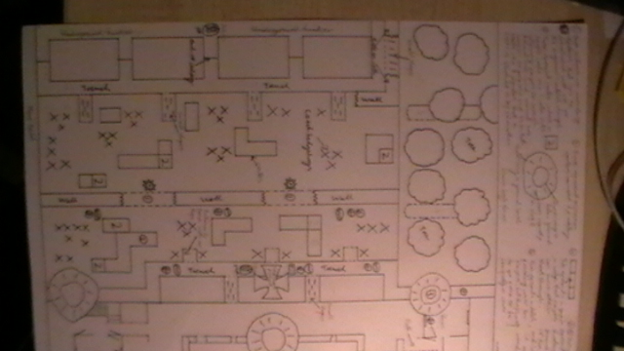Slope advance: This is the first stage of the map, where the Allies need to advance up the 20 degree slope, capture the control point and the Axis need to prevent this. The Axis spawn at the top of the slope, in the park area, which provides a safe spawn point (no spawn kills), where they can quickly take up defensive positions in the Axis trench, move down to the wall or stop off at crates and Czech hedgehogs along the way. The Axis doesn’t spawn in the trench because that is where the control point is located and it needs to be possible for the Allies to prevent the Axis from entering it, so it can be captured.

Capture point

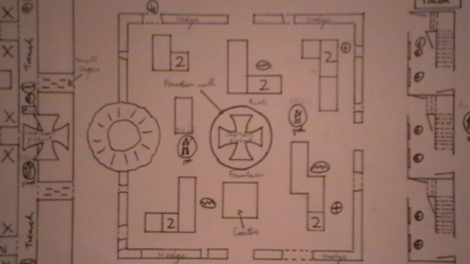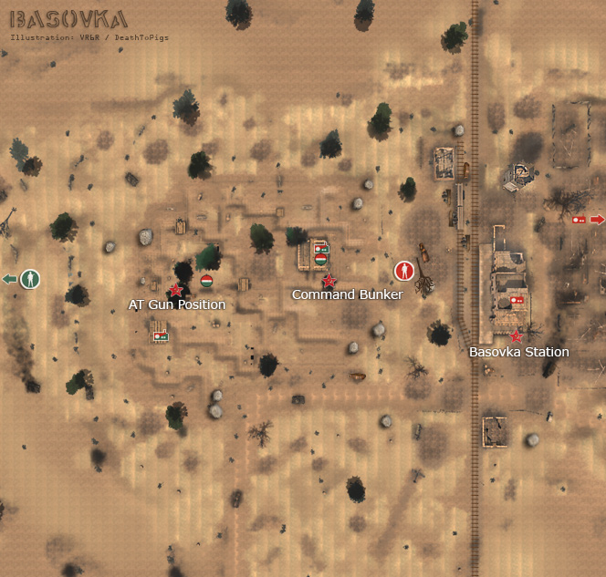

1st Axis spawn point

The Allies start at the bottom of the hill, in a bunker (which again provides a safe spawn point), that connects to a trench, that players can use as cover, mount their weapons on the parapet and provide covering fire up the slope, as their team mates advance up it.

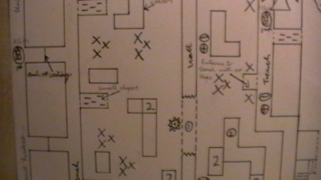

1st Allies spawn point



2nd Allies spawn point

Smoke and fragmentation grenades will be very useful in advancing up the slope because the squad leader’s smoke grenades will provide cover and frag grenades will help kill players in cover behind the wall, the crates and the Czech hedgehogs, and in the trench, allowing the team to advance more safely.

Good sniping position

 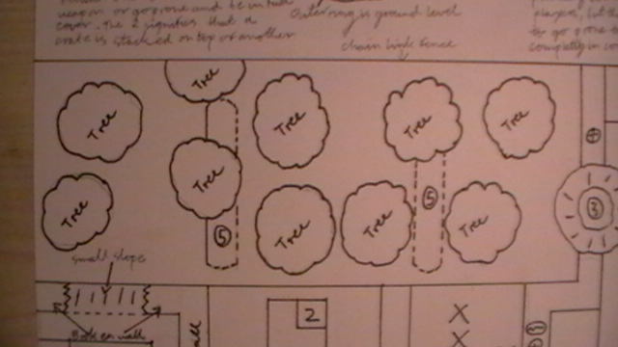The west side of the slope has a wood running up it, which spreads far to the west but players are restricted to how far they can go by a chain link fence, but there is still a lot of cover available to progress up the slope through the wood. Including a wood alters gameplay dynamics by creating natural and irregular cover, as opposed to the more structured design of the rest of the slope. It mixes up the gameplay into two distinct styles, the traditional WW2 “beach assault” style and the woodland combat style and providing this difference will keep the interest of players for longer.

Good defensive position

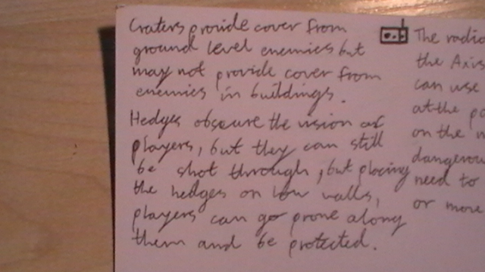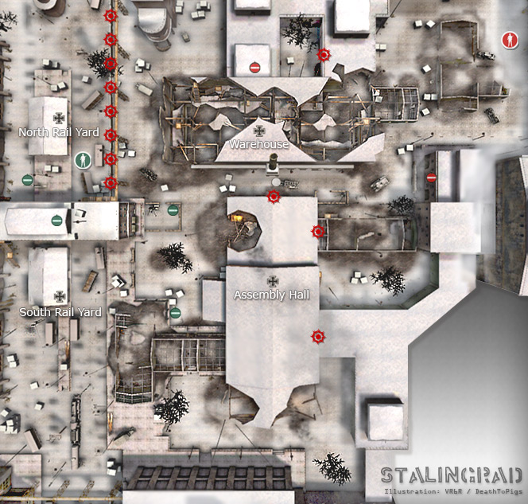 The wall is located about two thirds of the way up the slope; it comes to chest height and allows players to mount weapons to fire up or down the slope. It is impassable because it is too high to jump over and it runs across the entire width of the map (except for the woodland area). There are also two secondary objectives along the wall, where Allied engineers can demolish a section of the wall using satchel charges, allowing players to pass the wall and advance up the slope.

Arcs of fire

Axis sniper points

Secondary objectives: Satchel charge positions

Wall

Crates: Crates provide cover and allows player to mount their weapons on and they can be clustered in various shapes and sizes to alter player tactics. They can be stacked and arranged in groups at varying length, widths and heights, so players can stand and still be in cover with some, but with others they are required to crouch or go prone to stay in cover.

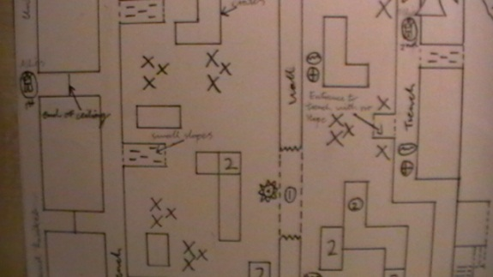

Crates

Crates

Good defensive positions



Czech hedgehogs

Czech hedgehogs

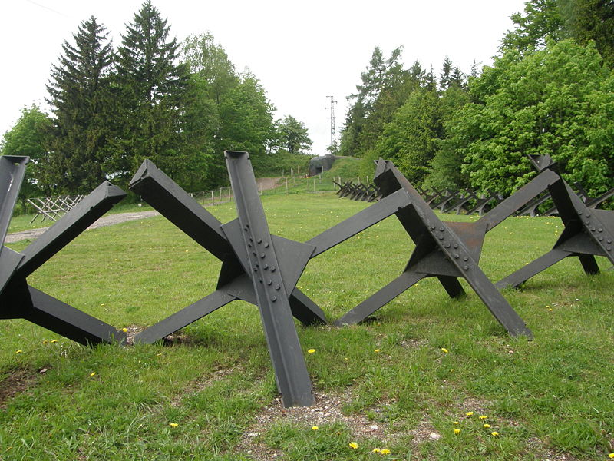

Fountain park: This is the second stage and it features a square ring road bordered by houses on the west, north and east fronts, with a park inside and a large fountain in its centre, which is also the centre of the second control point. There is a low wall with a hedge which is taller than the players, bordering the park, with a 2 metre wide openings in the middle of the west, north and east sides. With the south side, having a larger opening due to an explosion, which left a crater that Allies can use as a rally point and cover before advancing. The Axis spawn behind the northern row of houses and the Allies spawn in the Axis’ trench, again creating safe spawn points. Since there will still be some Axis players in combat with the Allies, along with some in the southern half of the park and in the houses, the re-spawning Axis players will have chance to move into defensive positions before the Allies can advance. By spawning the Axis behind the houses, the Allies will have chance to capture the control point by stopping the Axis from entering it.

Capture point



Openings in hedge

Crater



2nd Axis spawn point

2nd Allies spawn point

The Allies can move into the park via the crater or they can flank round the sides, this will allow them to ambush Axis players in the park, but they are also easy targets for any players in the houses. There are also small gaps in the hedging, caused from explosion shrappnel, gun fire or natural causes, which give players the opertunity to shoot through and can enter he park through larger ones. Inside the hedge border are various arrangements of crates surrounding the fountain, with the idea that this would been an Axis ammunition dump. Along with any players inside the park, there will be many players in the surrounding houses (especially on the first floor) targeting the park as well, creating a very dangerous place to be, providing the challenge of preventing Axis from entering the park, of capturing the control point and of staying alive (again smoke grenades will be very useful in concealing the team). By having Allies players in the houses targeting the park and other houses as well, will make it much easier for the Allies in the park to survive, creating fellowship in the team.

Gap in hedge

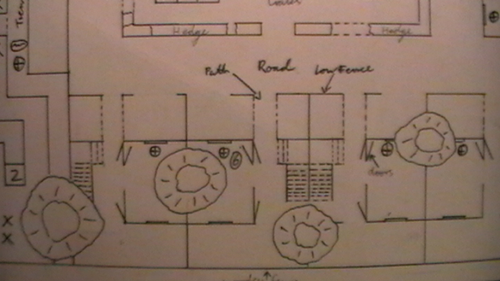

Allies’ flanking route

The houses along the east and west have front and back gardens separated by fences, that prevent players from passing from one to the next, but artillery has created gaps in some of the fences and left craters, either in the front or back gardens, or within the house itself. These gaps allow both Axis and Allies players to move from one to the next without going on to the road. It also creates excellent flanking routes for players, allowing them to get behind enemy lines, giving excellent firing angles on players behind cover. The houses have open doors leading into them from the front and back gardens, but some have holes in the walls caused by the artillery, allowing players to move into the house, from the garden more easily. Alternating where the gaps are (front/back garden or in the house), creates more complicated movement paths for players to follow, along with the possibility of an ambush at any moment, makes for a more tense and challenging gameplay, than simply running down a road. This also provides the discovery aesthetic to the gameplay because the players will want to learn the routes between one house to the next, along with possible ambush spots, so they can quickly move through the map. It also provides the sensation aesthetic for the player, because it shows that this area is a battleground with damaged buildings.

Axis’ flanking route

Axis route to flank Allies’ snipers.

Allies route to flank Axis’ snipers.

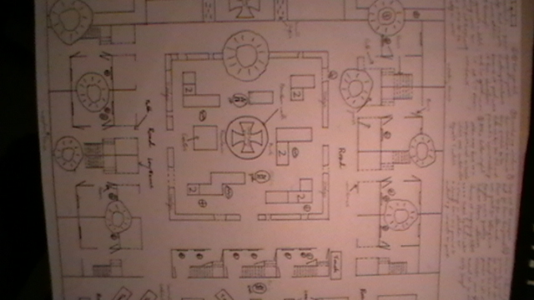

Arc of fire

Arc of fire

Arc of fire

Arc of fire

Arc of fire

Arc of fire

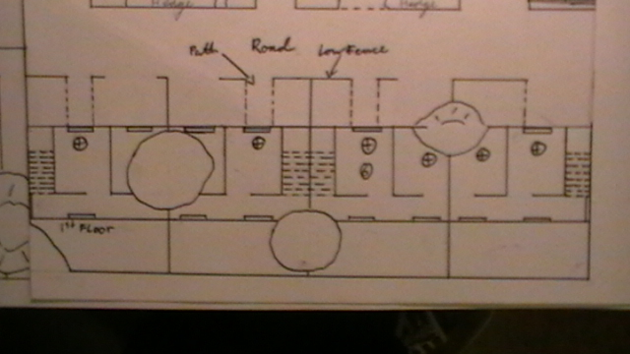

Sniper points

Whilst advancing through the houses players can stop off at one of the 1st floor windows or holes in the walls and shoot at players on the ground or across the park at players in the other houses. These positions are brilliant for snipers, riflemen and support gunners, because they have wide firing arcs across.

Good defensive positions



Crater





East row

North row

West row

Houses: There are three rows of housing in the map, two rows running along the east and west sides, both starting from the top of the slope running along the roads to the main road and one along the north side of the park. Each house has two floors and all of them can be entered, meaning that there are many angles that the Axis can supress the Allies from, this forces the Allies to always be aware of their surroundings. All of the 1st floor windows provide excellent arcs of fire and are perfect for snipers, but they are also dangerous because players will be targeting the windows waiting for them to show themselves or they will be coming up from behind, taking advantage of their blind spot.

Mansion: This is the third stage and it’s based in and around a mansion which acts as the Axis’ headquarters (HQ) for the area and it contains the last control point. It has three levels to it, two normal floors and a large attic, with the control point positioned in the attic, meaning that the Allies will need to ascend through each level to reach it. This brings some verticality and close quarters combat to the gameplay, which contrasts to the more open environments of the first and second stages, so players will have to change tactics on the fly. For example an Allies’ sniper won’t be very useful inside the mansion, but he will be useful in killing Axis players in the windows, who are attempting to stop his team from entering the mansion. Also players will want to switch to assault troopers or semi-auto riflemen (if not already full) because they are more lethal in close quarters than bolt action rifles.

Allies sniper points

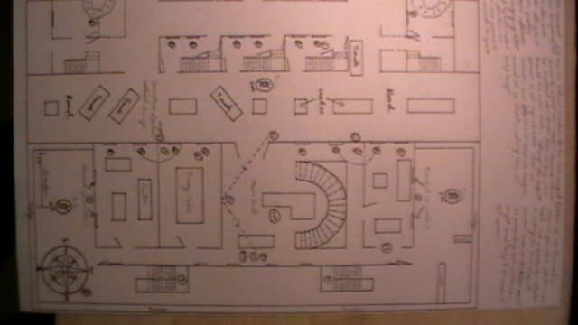

Axis sniper points



Arcs of fire



3rd Axis spawn points

3rd Allies spawn point



The Axis spawns in the mansion’s garden, either on the west or east side and can enter the mansion from the side doors or climb up either fire escape, which are located at the back and takes players directly to the 1st floor and the attic. The Allies spawn in the park area and they are protected from spawn killing by the northern row of houses.

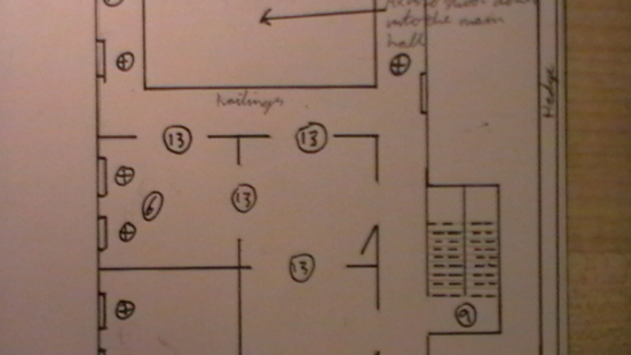

Fire escape



Allies route of advance

Entering the mansion through the main doors is very dangerous because the main hall is a high combat area, since Axis players will be targeting the main doors from around corners, behind crates, the stairs and from the 1st floor balcony. This will mean that the Allies will be throwing lots of frag and smoke grenades into the main hall, in an attempt to make it safer to enter. Either side of the main doors, there is a secondary objective, where engineers can place satchel charges, to demolish a section of the wall, making it much easier to enter the mansion. This will create high combat areas, because the Allies will want to demolish the wall and the Axis will want to stop them, creating a lot of focus on these areas.

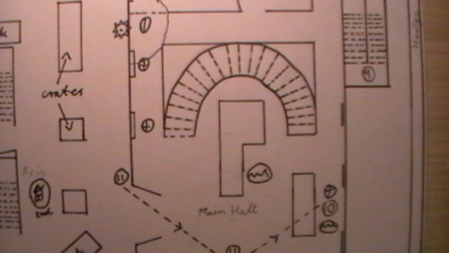

Grenade rebound wall

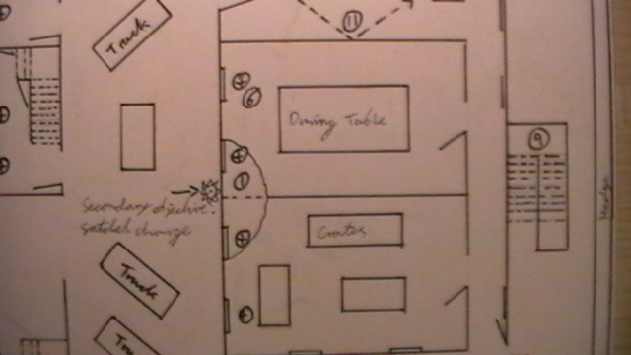

Secondary objective: Satchel charge placement position

Good position for Axis support gunner, since he has an excellent view of the main doors.





1st stage Allies spawn point

2nd stage Axis spawn point



1st stage Axis spawn point

2nd stage Allies spawn point



3rd stage Allies spawn point

3rd stage Axis spawn points



High combat areas

Allies will want to demolish wall and Axis will want to stop them, creating an area of high combat.



Allies main advance route

Axis flanking routes

Axis main advance route

Allies flanking route

Stage one – Advance routes



Allies main advance route

Axis flanking routes

Axis main advance route

Allies flanking route

Stage two – Advance routes

Axis flanking routes

If both the Allies and the Axis are trying to flank the main advance on the same side and at the same time, then they will clash.



Axis main advance routes, there are two because there are two spawn points and it is random which one the player spawns at.

Allies main advance route

Axis flanking routes

Axis flanking route (up the fire escape).

Axis flanking route (up the fire escape).

Stage three – Advance routes

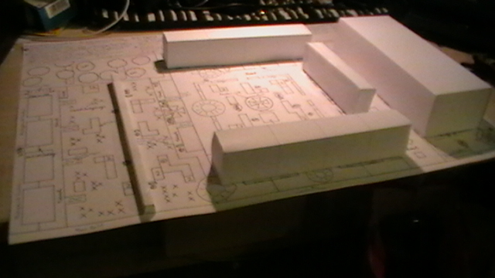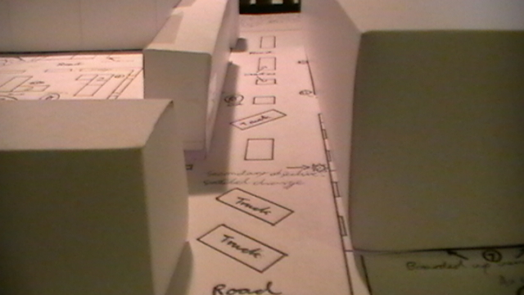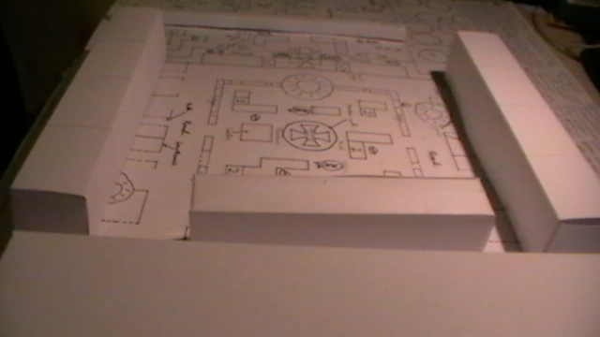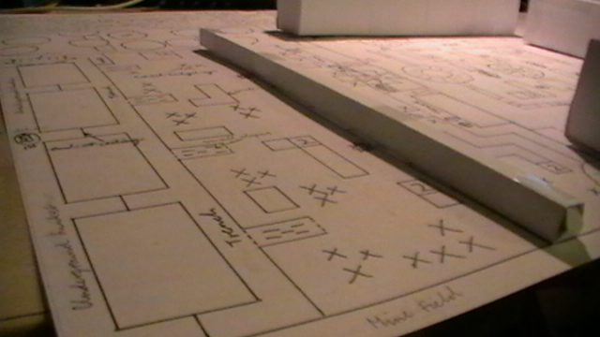

Photos of 3D buildings

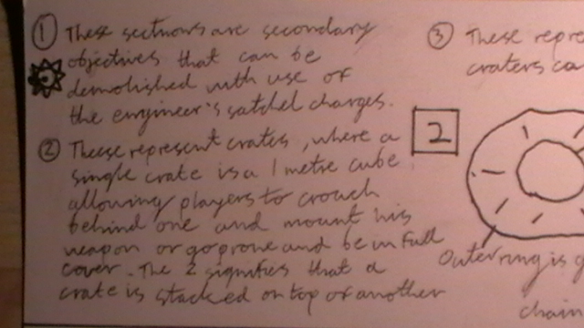



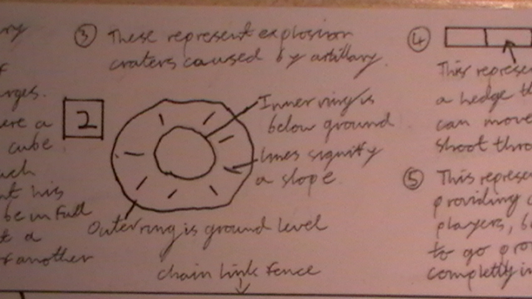

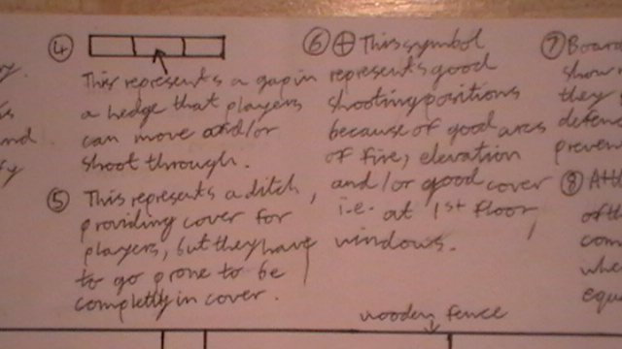

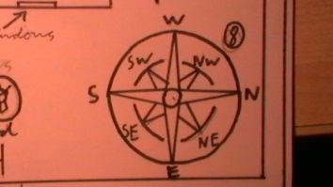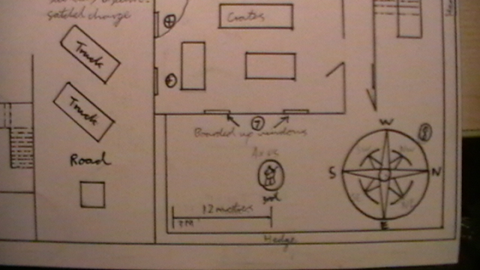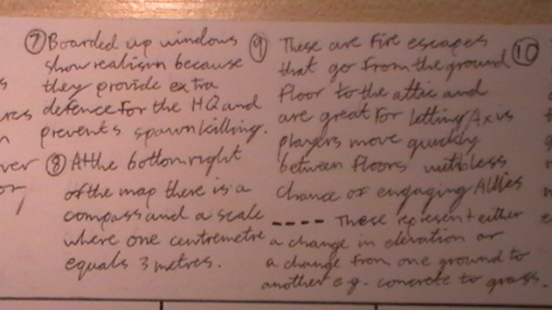

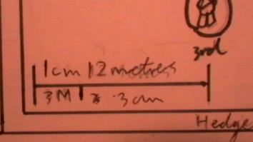

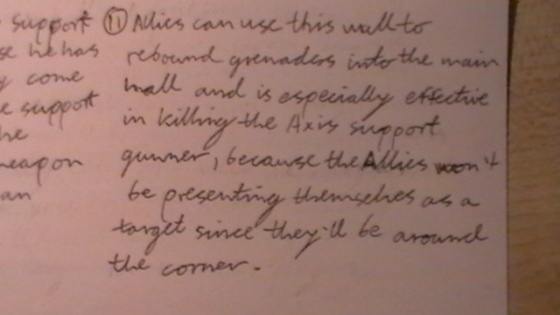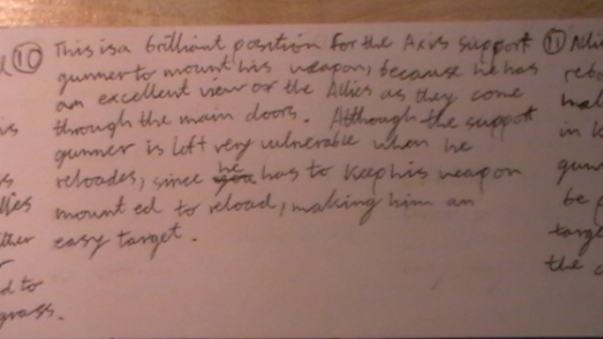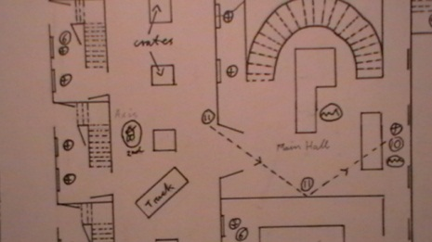

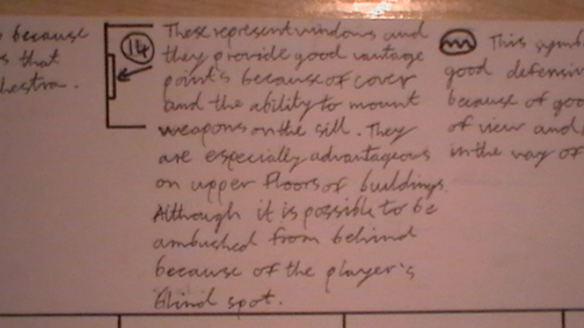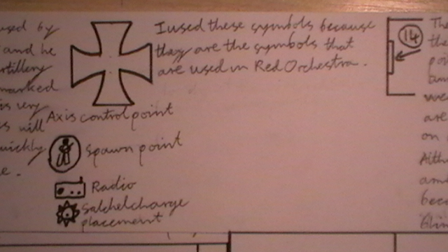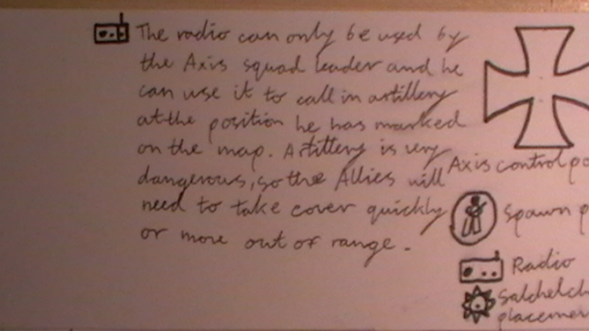



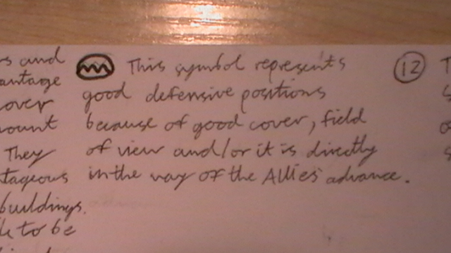

I chose to draw the symbol like this, because it’s like mountains and mountains are strong.

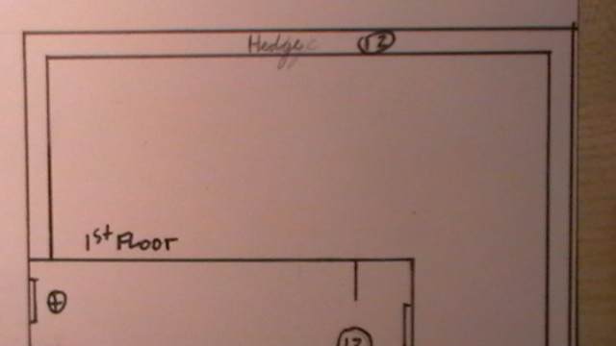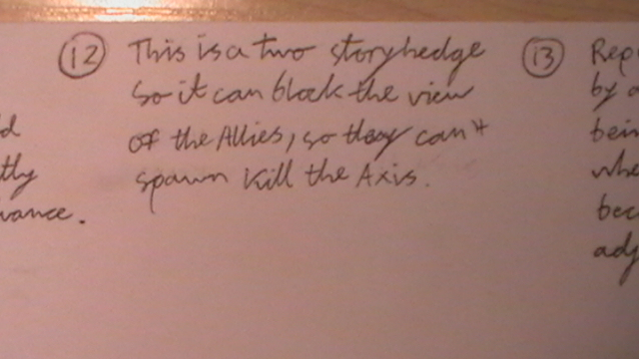

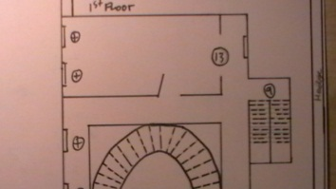

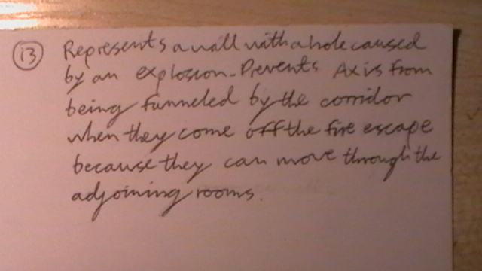

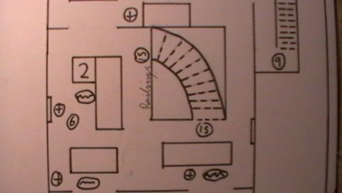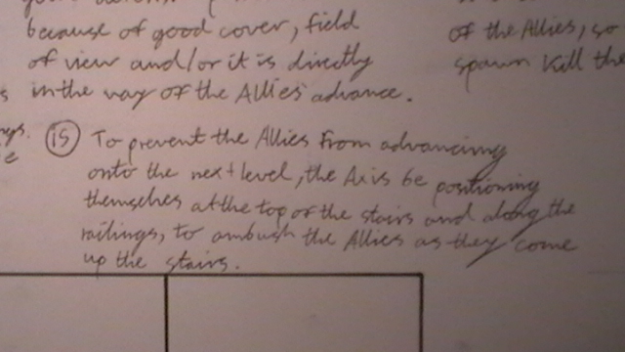

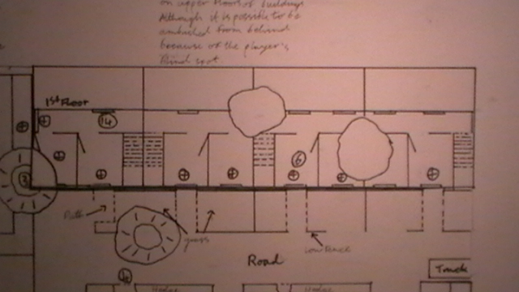

1st floor, west houses.



1st floor, east houses.

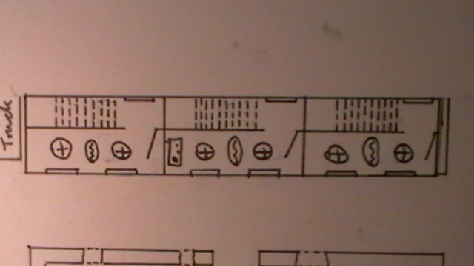

1st floor, north houses.

Mansion, 1st floor.

Mansion, 2nd floor (attic).

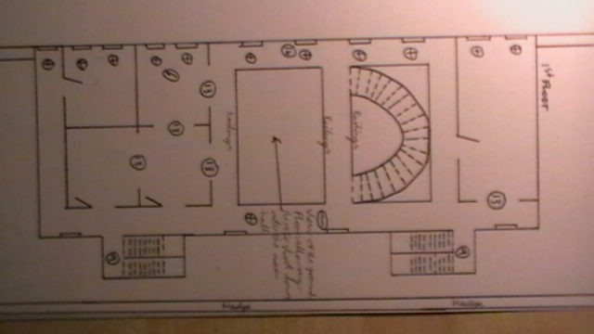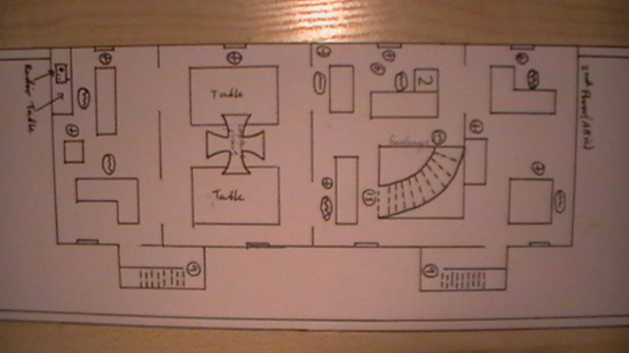

Capture point



Good sniping and defensive positions, sometimes go together,







Mansion, 1st floor.



Mansion, 2nd floor (attic).

